1. Given a list of numbers, create a function that removes 25% from every number in the list except the smallest number, and adds the total amount removed to the smallest number.

**Examples**

show_the_love([4, 1, 4]) ➞ [3, 3, 3]

show_the_love([16, 10, 8]) ➞ [12, 7.5, 14.5]

show_the_love([2, 100]) ➞ [27, 75]

**ANS:** 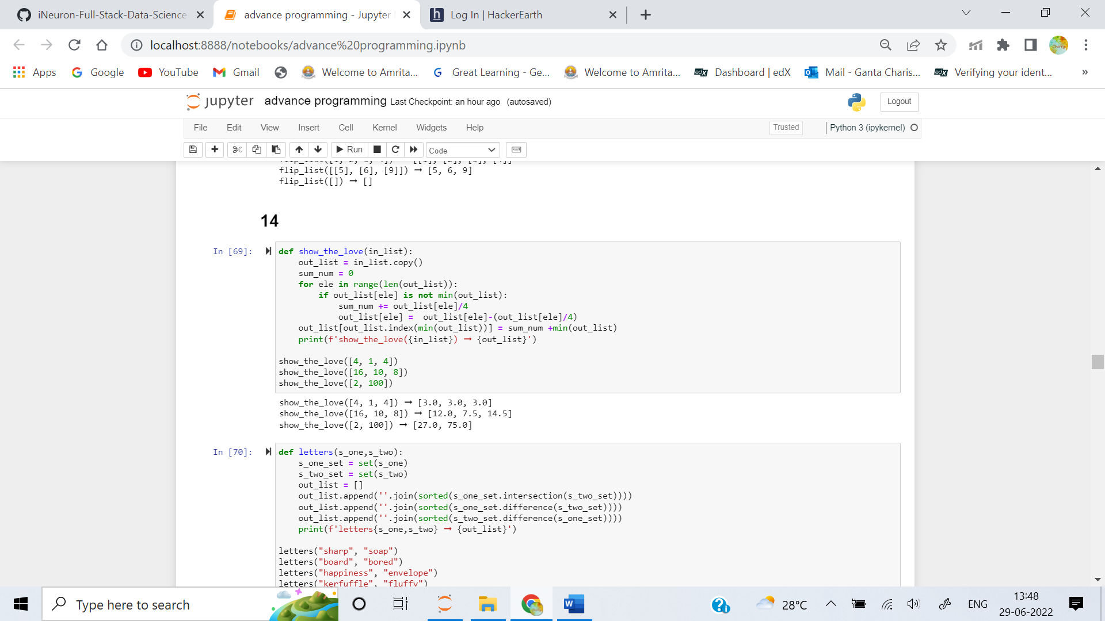

2. Create a function that takes in two words as input and returns a list of three elements, in the following order:

1.Shared letters between two words.

2.Letters unique to word 1.

3.Letters unique to word 2.

Each element should have unique letters, and have each letter be alphabetically sorted.

**Examples**

letters("sharp", "soap") ➞ ["aps", "hr", "o"]

letters("board", "bored") ➞ ["bdor", "a", "e"]

letters("happiness", "envelope") ➞ ["enp", "ahis", "lov"]

letters("kerfuffle", "fluffy") ➞ ["flu", "ekr", "y"]

# Even with multiple matching letters (e.g. 3 f's), there should

# only exist a single "f" in your first element.

letters("match", "ham") ➞ ["ahm", "ct", ""]

# "ham" does not contain any letters that are not found already

# in "match".

**ANS:** 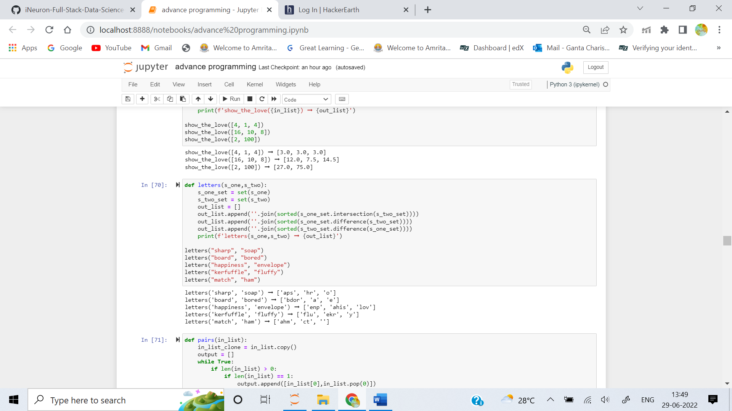

3. Write a function that pairs the first number in an array with the last, the second number with the second to last, etc.

**Examples**

pairs([1, 2, 3, 4, 5, 6, 7]) ➞ [[1, 7], [2, 6], [3, 5], [4, 4]]

pairs([1, 2, 3, 4, 5, 6]) ➞ [[1, 6], [2, 5], [3, 4]]

pairs([5, 9, 8, 1, 2]) ➞ [[5, 2], [9, 1], [8, 8]]

pairs([]) ➞ []

**ANS:** 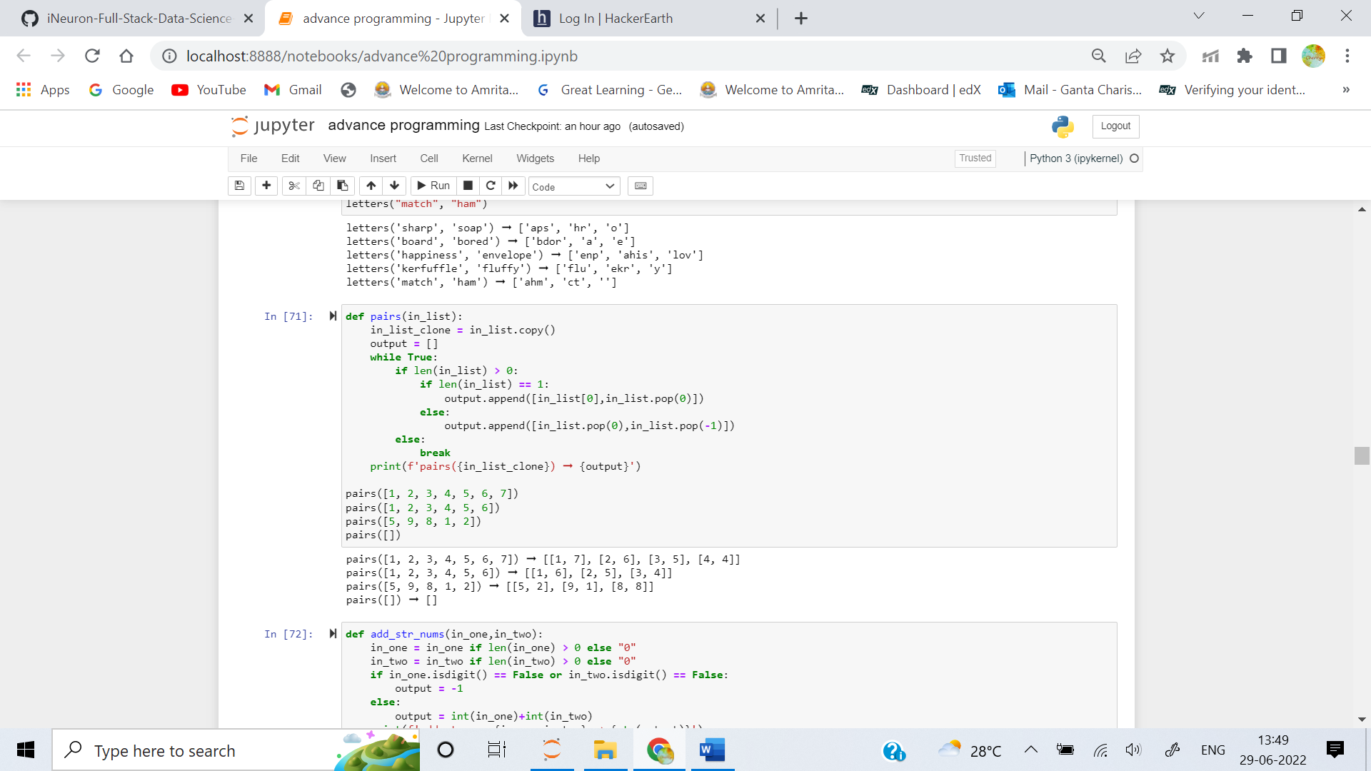

4. Write a function that adds two numbers. The catch, however, is that the numbers will be strings.

Examples

add_str_nums("4", "5") ➞ "9"

add_str_nums("abcdefg", "3") ➞ "-1"

add_str_nums("1", "") ➞ "1"

add_str_nums("1874682736267235927359283579235789257", "32652983572985729") ➞ "1874682736267235927391936562808774986"

**ANS:** 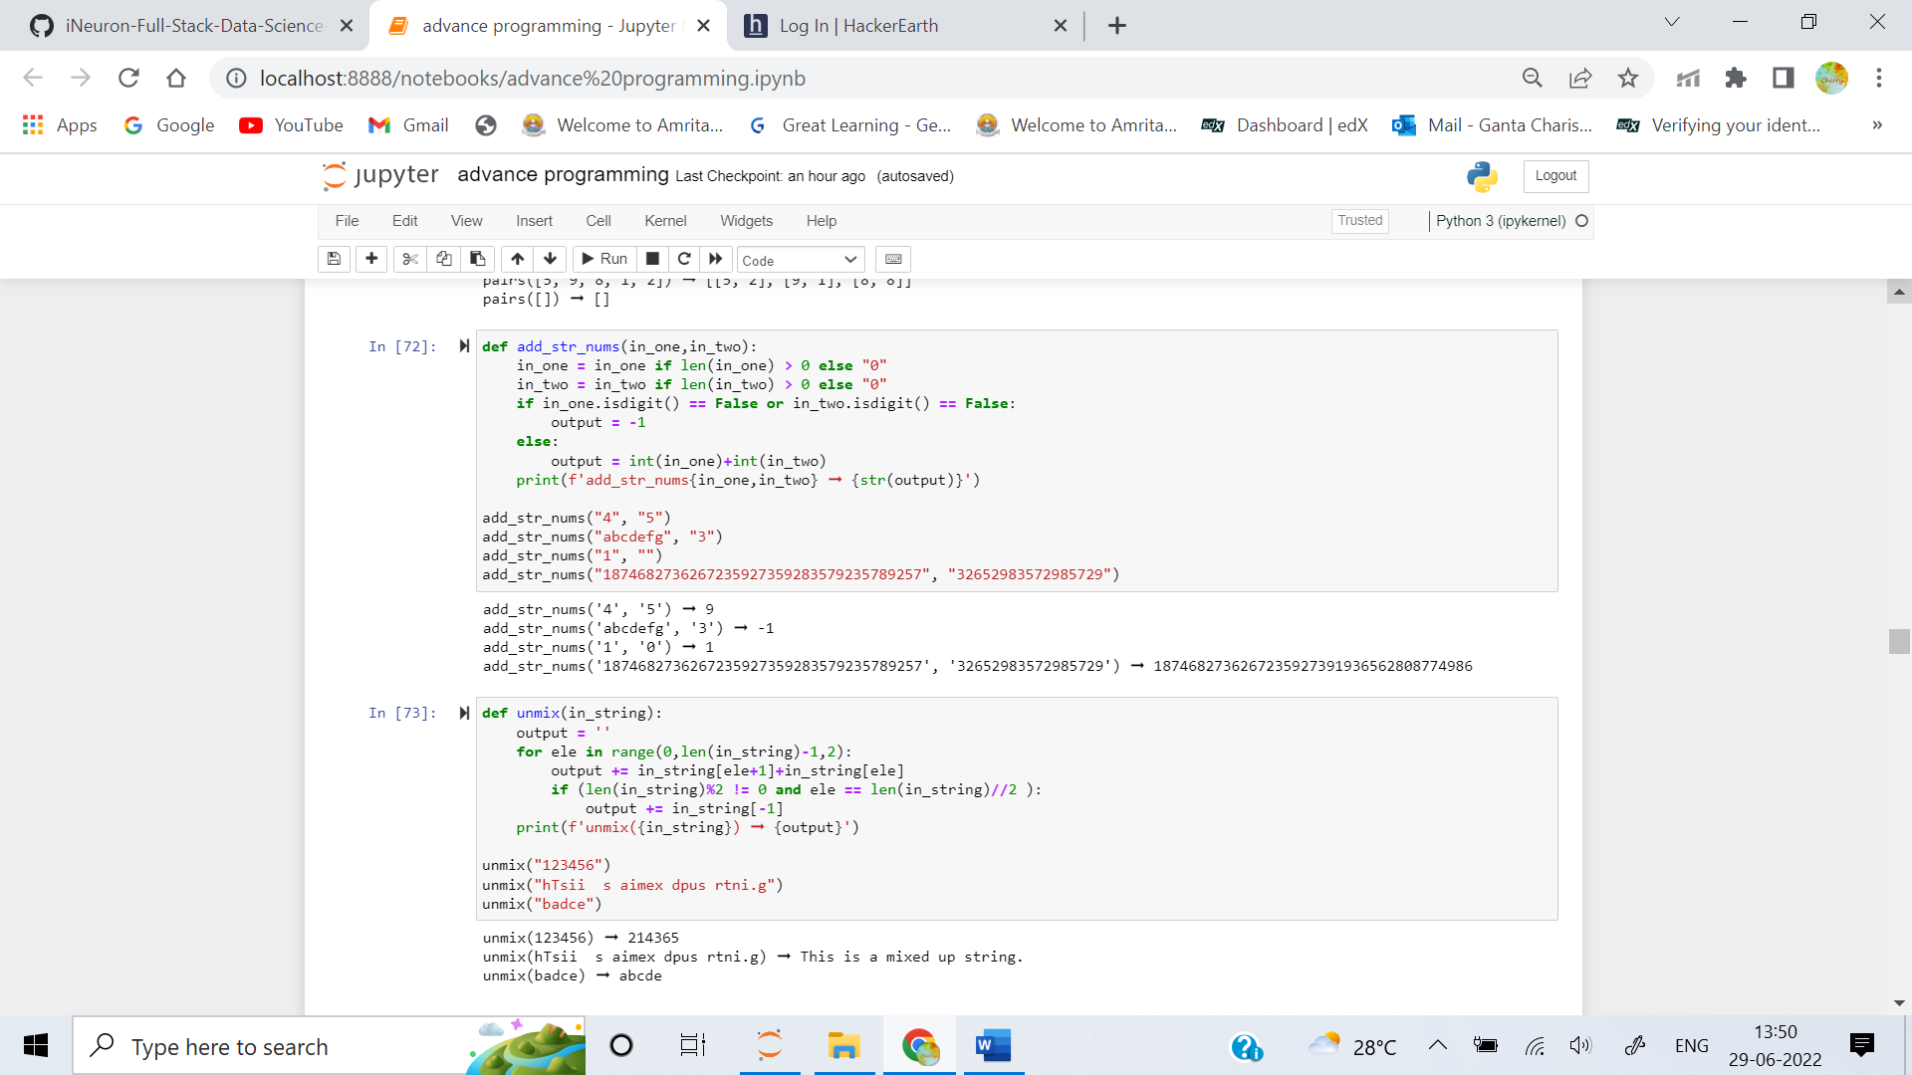

5. lPaeesh le pemu mnxit ehess rtnisg! Oh, sorry, that was supposed to say: Please help me unmix these strings!

Somehow my strings have all become mixed up; every pair of characters has been swapped. Help me undo this so I can understand my strings again.

Examples

unmix("123456") ➞ "214365"

unmix("hTsii s aimex dpus rtni.g") ➞ "This is a mixed up string."

unmix("badce") ➞ "abcde"

**ANS:** 